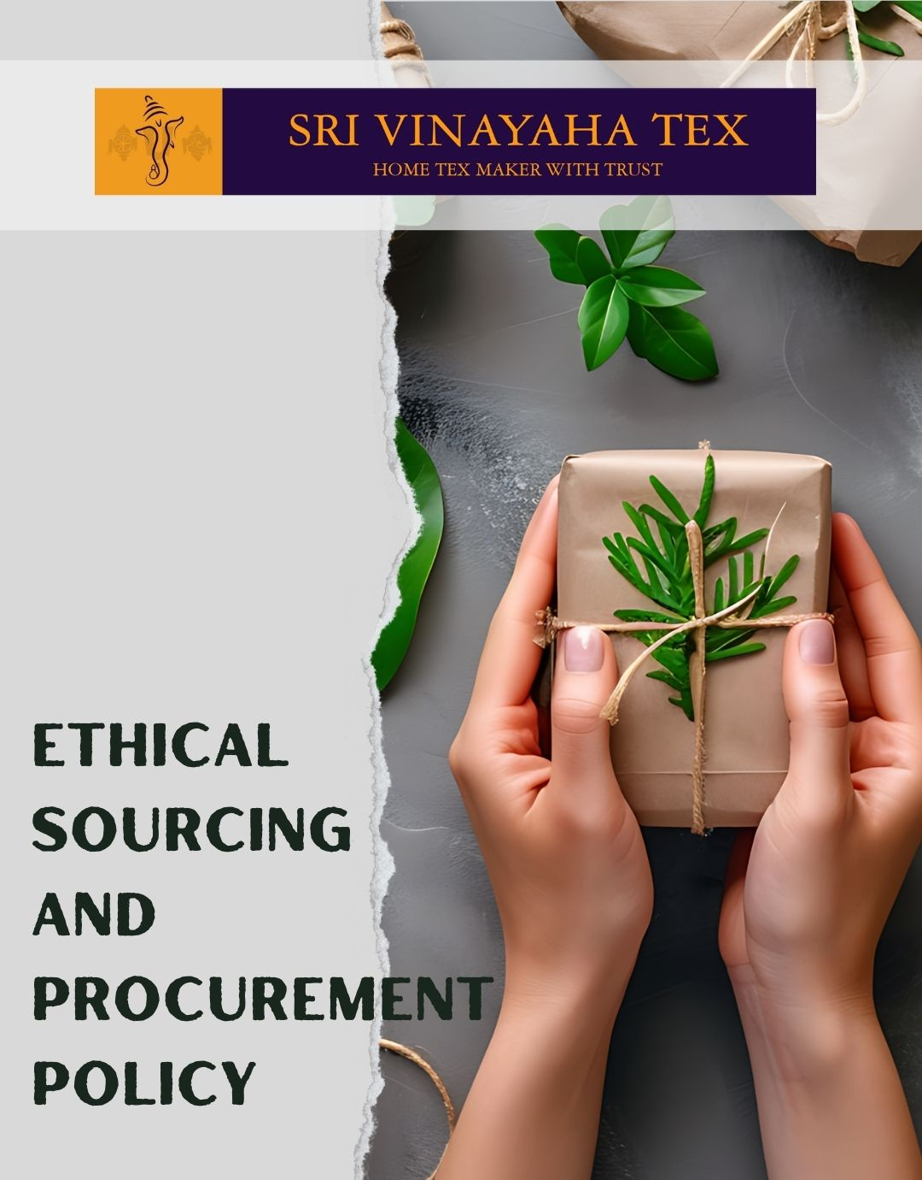

TABLE OF CONTENTS
PROLOGUE 2
SCOPE 2
POLICY DECLARATION 2
INITIATIVES AND TARGETS IN ALIGNMENT WITH SDGs 3
PERFORMANCE REPORTING 4
REVIEW MECHANISM 4

PROLOGUE

At Sri Vinayaha Tex, our commitment to ethical sourcing and procurement is fundamental to our business ethos and operational integrity. As a global leader in textile manufacturing, we recognize that our procurement practices have far-reaching impacts on the environment, communities, and economies.
This Ethical Sourcing and Procurement Policy is crafted to guide our procurement decisions and processes, ensuring that we uphold the highest standards of ethical behavior throughout our supply chain. We are dedicated to source materials and products responsibly, ensuring that our suppliers adhere to rigorous environmental, social, and ethical standards. This policy reflects our dedication to fostering transparency, promoting sustainability, and ensuring that every aspect of our procurement aligns with our core values of integrity, fairness, and respect. Through this commitment, we aim to build a supply chain that not only meets our quality and efficiency standards but also contributes positively to the global community and environment.

SCOPE

This Policy is applicable to following sites and all of its employees, workers, sub-contractors and other stakeholders:

Sr. No. | Site | Address
1 | SHRI VINAYAHA TEX
2 | SHRI VINAYAHA TEX

POLICY DECLARATION

Sri Vinayaha Tex is firmly committed to upholding the highest standards of ethical conduct in all our sourcing and procurement activities. This policy declares our dedication to conducting procurement with transparency, integrity, and a strong focus on sustainability. We require all suppliers to adhere to rigorous standards related to environmental impact, fair labor practices, and ethical behavior. Our aim is to ensure that every procurement decision reflects our core values of responsibility and respect for both people and the planet. Year 2023 is used as the baseline year for evaluating performance and progress against the policy's targets and goals. Through this policy, we pledge to enhance our practices and collaborate with partners who share our values.

INITIATIVES AND TARGETS IN ALIGNMENT WITH SDGs
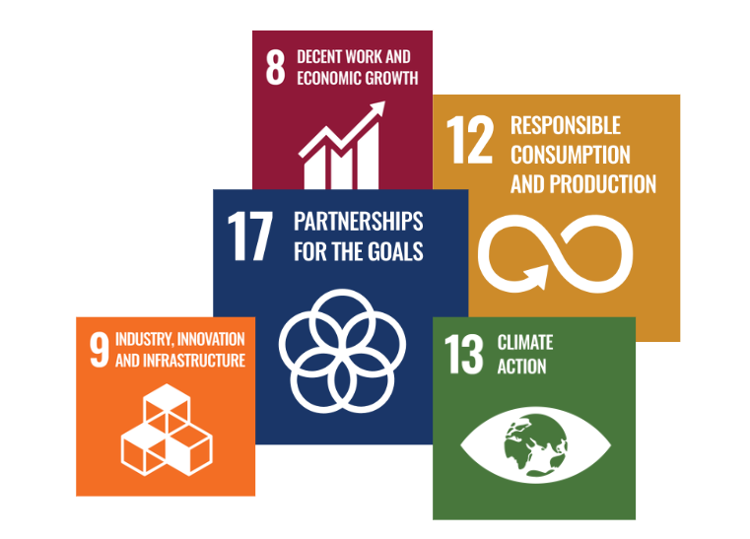

- Develop and implement a comprehensive environmental impact assessment for all new suppliers to evaluate their environmental practices and compliance with sustainability standards.
- Achieve a 90% or higher rate of suppliers undergoing environmental impact assessments annually by year 2030.
- Establish a transparent supply chain tracking system to monitor and disclose the origin of materials, ensuring traceability from source to final product.
- Ensure that 100% of key suppliers provide full transparency regarding their supply chain, and conduct annual audits to verify the accuracy of this information by year 2030
- Implement a supplier code of conduct that outlines our labor practices and human rights expectations, including fair wages, safe working conditions, and the prohibition of child and forced labor.
- Achieve a 100% compliance rate with the supplier code of conduct among all tier-one suppliers by year 2030 and conduct annual audits to ensure ongoing adherence.
- Promote circular economy practices by encouraging suppliers to adopt waste reduction strategies and implement product take-back programs.
- Collaborate with 80% of suppliers to develop and execute circular economy initiatives, aiming for a 10% reduction in waste generated through our supply chain by year 2030.

PERFORMANCE REPORTING

Performance against the Ethical Sourcing and Procurement Policy will be evaluated and reported annually. This reporting process will include a comprehensive overview of our achievements in meeting the policy’s targets, as well as an analysis of any challenges faced. Each report will provide detailed metrics on key areas such as supplier compliance with ethical and sustainability standards, progress in reducing environmental impact, and adherence to labor practices. Additionally, the reports will highlight areas where improvements are needed and outline action plans to address any deficiencies. These reports will be shared with senior management and stakeholders to ensure transparency and to guide ongoing efforts toward enhancing our procurement practices in alignment with our core values and goals.

REVIEW MECHANISM

The Ethical Sourcing and Procurement Policy will be reviewed annually by the Chief Sustainability Officer to ensure its continued effectiveness and relevance. This review process will assess the policy’s alignment with current legal requirements, industry standards, and organizational goals. The Chief Sustainability Officer will evaluate performance data, feedback from stakeholders, and any emerging trends or issues in ethical sourcing and procurement. Updates to the policy will be made as necessary to address identified gaps, improve practices, and enhance compliance. Employees and suppliers are encouraged to provide feedback and report any concerns to the Chief Sustainability Officer, who will incorporate this input into the review process to ensure ongoing refinement and improvement of our procurement practices.

REV. No. 01

EFFECTIVE FROM: 01.01.2024 NEXT REVIEW DATE: 01.01.2025
APPROVED BY: PRESIDENT - OPERATIONS

